Practical No. 8
Aim : WAP to implement Single Inheritance

Name : Danish Altaf Solkar | Class : CO - B
Enrolment no. : 24111590805 | Batch : 2

Code :-
class Animal
{
void sound()
{
System.out.println("Animal makes sound");
}
}
class Dog extends Animal
{
void sound()
{
System.out.println("Dog barks");
}
}
public class Singleinheritance
{
public static void main(String [] args)
{
Dog dog = new Dog();
dog.sound();
}
}

OUTPUT :-
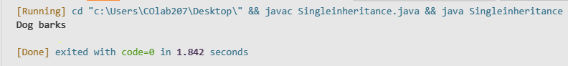
Process related  (35) | Product related  (15) | Total Marks  (50) | Signature

Practical No. 8
Aim : WAP to implement Multilevel Inheritance
Name : Danish Altaf Solkar | Class : CO - B
Enrolment no. : 24111590805 | Batch : 2
Code :-
class Vehicle
{
void type()
{
System.out.println("Vehicle type : Car");
}
}
class Car extends Vehicle
{
void brand()
{
System.out.println("Car brand : Toyota");
}
}
class Sedan extends Car
{
void model()
{
System.out.println("Car model : Camry");
}
}
public class Multilevelinheritance
{
public static void main(String [] args)
{
Sedan s = new Sedan();
s.type();
s.brand();
s.model();
}
}
OUTPUT :-
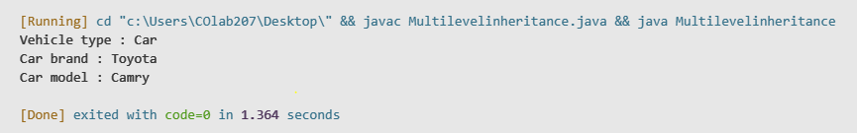
Process related  (35) | Product related  (15) | Total Marks  (50) | Signature
Practical No. 8
Aim : Develop a program to implement the Multilevel Inheritance
Name : Danish Altaf Solkar | Class : CO - B
Enrolment no. : 24111590805 | Batch : 2
Code :-
class Roomarea
{
protected double l,b;
Roomarea(double len,double br)
{
l = len;
b = br;
}
void putdat()
{
System.out.println("Area of Room : "+(l*b));
}
}
class Roomvol extends Roomarea
{
double h;
Roomvol(double len, double br, double he)
{
super(len,br);
}
void putdata()
{
super.putdata();
System.out.println("Volume of Room : "+(l*b*h));
}
}
public class RoomAreaVolume
{
public static void main(String [] args)
{
Roomvol r1 = new Roomvol(15,20,15);
r1.putdata();
}
}
OUTPUT :-
Process related  (35) | Product related  (15) | Total Marks  (50) | Signature

